Software Requirements Specification

for

“Art Hub”

Version 1.6

Prepared by Savu Beniamin, Suliță Cosmin, Stîngă-Olteanu Ramona, Tolgoi Gabriel

March 11, 2017

Table of Contents

1. Introduction 1

1.1 Purpose 1

1.2 Product Scope 1

1.3 References 1

2. Overall Description 1

2.1 Product Perspective 1

2.2 Product Function 2

2.3 User Classes and Characteristics 2

2.4 Operating Environment 2

2.5 Design and Implementation Constraints 2

2.6 User Documentation 2

2.7 Assumptions and Dependencies 2

3. External Interface Requirements 3

3.1 User Interfaces 3

3.2 Hardware Interfaces 3

3.3 Software Interfaces 3

3.4 Communications Interfaces 3

4. System Features 4

4.1 Account Registration 4

4.2 Account Login 4

4.3 Account Logout 4

4.4 Admin Add Member 5

4.5 Admin Edit Member 5

4.6 Admin Modify Resource 5

4.7 Admin Define Payment 6

4.8 Admin Generate Reports 6

4.9 User create event 6

4.10 User edit event 7

4.11 User view events 7

5. Other Nonfunctional Requirements 8

5.1 Performance Requirements 8

5.2 Safety Requirements 8

5.3 Security Requirements 8

5.4 Software Quality Attributes 8

5.5 Business Rules 8

6. Other Requirements 8

# Introduction

## Purpose

The purpose of this document is to define the system requirements for a distributed system that manages the activities of an art-enthusiasts' club. It will explain the purpose and features of the system, the interfaces of the system, what the system will do, the constraints under which it must operate and how the system will react with the users.

## Product Scope

*This software system will be a web application for a local art club. This system will be designed to ease the administrators’ management activities and also help the club’s members to easily set up conferences & art exhibitions. This system is designed to allow an administrator to add new places where the club’s members can perform meetings and exhibitions, manage the users’ payments and accounts. The system also contains a relational database containing a list of conference rooms, art galleries and user data.*

## References

*IEEE. IEEE Std 830-IEEE Recommended Practice for Software Requirements*

# Overall Description

## Product Perspective

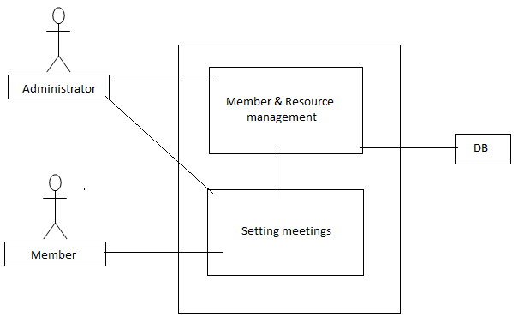

*The “Art Hub” system is a virtually self-contained scheduling system; however, it will require users to have access to a web browser on their workstation computer. This means that the users of the system do not need to invest in any other software to get the most out of this software system.*

## Product Function

* Login
* New user registration
* New admin registration
* Admin manages user accounts
* Setting up conferences & art exhibitions
* Managing payment
* Generating reports (Eg: cost reports)

## User Classes and Characteristics

The application users will be club employees which will have administrator privileges and citizens which will have regular member accounts.

## Operating Environment

As mentioned before the “Art Hub” will require users to have access to a web browser on their workstation computer like Google Chrome or Mozilla Firefox.

## Design and Implementation Constraints

Creating a user interface which is both effective and easily navigable will pose a difficult challenge. Other constraints such as a weak web-host and slow internet browsers (“Internet Explorer”) are also worth considering. Art Hub is meant to be quick and responsive, even when dealing with large groups and transactions, so each feature must be designed and implemented with efficiency in mind.

*Backend language: Java*

*Frontend: HTML, CSS, JavaScript*

*Framework: Spring MVC*

## User Documentation

*NA*

## Assumptions and Dependencies

The web application assumes that the user has a computer with an Internet connection and a web browser to access “Art Hub”. The system may not behave correctly when used with internet browsers other than Firefox and Google Chrome.

# External Interface Requirements

## User Interfaces

*The layout should be as follows:*

* *The header which displays:* 
  + - *the logo*
    - *the currently logged user*
    - *the “Logout” and “Manage Account” menu*
  + *The body, which displays* 
    - *the menu, immediately under the header*
    - *the content(events already created)*
  + *The footer, which displays* 
    - *contact*
    - *copyright*

*There will be two different user interfaces that will accompany this website: one for the club’s members and one for the administrators.*

*Club’s members will be able to pay a fee and invite other members in order to book conference or art exhibitions rooms. The invetees are able to see the events at which they were invited to.*

*The administrators will be able to add or remove members, new conference/ exhibition rooms and also change the room booking price.*

## Hardware Interfaces

NA

## Software Interfaces

The application is connected to a database (MySQL). The database will communicate with the server, and the server will send the information to the client application. The information will consist of data regarding the time and place of the meetings (shared between users), user credentials, payment details. The serer will communicate with the database via some classes from an external jar. The server will know about those classes after adding an xml file with the proper configuration such as specifying the DriverManagerDataSource class which is responsible for the jdbc driver and the database url. Also the basic database operations(create, update, read, delete) are defined in this jar by the EntityManagerFactory class which will be also configured in the xml file.

## Communications Interfaces

HTTP will be the communication protocol that “Art Hub” will use.

# System Features

## Account Registration

4.1.1 Stimulus: Click "Register" Button

4.1.2 Functional Requirements

* The system shall allow a non-registered user to create a secure account.
* The system shall require the following information from the user:

1. First name (max 20 chars)
2. Last name (max 20 chars)
3. Username (max 20 chars)
4. Password (must contain uppercase letter, a number and a special character)
5. Email (has to be a valid mail, <user>@<domain>)

* The system shall confirm the username, email and password are acceptable.
* The system shall store the information in the database.

All fields are mandatory and are to be written in the text boxes offered by the registration interface. If the request passes, the user will receive a validation email. He must confirm it otherwise the account will be deleted in 1 day. If the request doesn’t pass the user will be informed with the error and can try again.

## Account Login

4.2.1 Stimulus: Click "Login" Button

4.2.2 Functional Requirements

* The system shall allow a registered user to log-in to their account.
* The system shall require a username and password from the user.
* The system will verify the username and password, and the user will be considered “logged-in”.

All fields are to be written in the text boxes offered by the login interface.

## Account Logout

4.3.1 Stimulus: Click "Logout" Button

4.3.2 Functional Requirements

* The system shall allow the registered and logged-in user to exit his/her account, so that access to operations requiring a user to be logged in are now disabled

## Admin Add Member

4.4.1 Stimulus: Click "Add Member" Button

4.4.2 Functional Requirements

* The system shall allow a logged-in admin to create new member accounts and new admin accounts.
* Only admins can add new admins.
* The system shall require a username from the logged-in admin

The username field shall be written in a text box offered by the admin interface.

## Admin Edit Member

4.5.1 Stimulus: Click "Edit Member" Button

4.5.2 Functional Requirements

* The system shall allow a logged-in admin to edit a registered member
* The system shall require a username from the logged-in admin
* The system shall display all the information regarding that user with the possibility of modifying data such as user, password, privileges.
* After those modifications the system shall inform the respective member that his information/details have been modified

The username field shall be written in a text box offered by the admin interface.

## Admin Modify Resource

4.6.1 Stimulus: Click "Modify Resource" Button

4.6.2 Functional Requirements

* The system shall allow a logged-in admin to modify an available resource
* The system shall require the name of the resource from the logged-in admin
* The system shall display all the information regarding that resource with the possibility of modifying it’s time allocation, room member capacity and availability.

The resource name field shall be written in a text box offered by the admin interface.

## Admin Define Payment

4.7.1 Stimulus: Click "Define Payment" Button

4.7.2 Functional Requirements

* The system shall allow a logged-in admin to define a payment.
* The system shall require the name of the resource.
* The system shall display the fees regarding that resource with the possibility of modifying it.

The resource name field shall be written in a text box offered by the admin interface.

## Admin Generate Reports

4.8.1 Stimulus: Click "Generate Reports" Button

4.8.2 Functional Requirements

* The system shall allow a logged-in admin to generate a report.
* The admin will be able to select between three types of reports:
  + Income reports
  + Resource availability reports
  + Profit reports
* Each type of report will display the corresponding data:
  + The income reports will display the name of the user and a corresponding due amount.
  + The resource availability reports will display the room name, its type and its entire schedule.
  + The profit reports will display all the incomes and costs and also a total that has been earned during a month.

## User create event

4.9.1 Stimulus: Click "Create event" Button

4.9.2 Functional Requirements

* The system shall allow a logged-in user to create a new event: a conference or an art exhibition.
* The user will have to choose from a list of conference or exhibition rooms the time frame, the actual room and also who will attend to the newly created event.
* Once those have been decided the user must confirm their choice and perform the required payment.
* The payment sum will automatically be subtracted from the current user’s balance.
* This feature is not available if the total income is lower than the total cost in that month.

The resource will be selected from a drop-down menu offered by the create event interface. The time frame (24 hour format) shall be written in a text box offered by the create event interface. The soon-to-be-invitees will be added to the event using their username in a text box offered by the create event interface.

## User edit event

4.10.1 Stimulus: Click "Edit event" Button

4.10.2 Functional Requirements

* The system shall allow a logged-in user to edit an existing event.
* The user will have to choose from a list of existing events created by him.
* The user can change the room, the invitee list and the time interval in which the event will take place.
* All those changes can be done in two days since the event creation.
* Canceling an event is possible, but only after paying a sum of 50 pirate gold doubloons/lei (preferably doubloons)

## User view events

4.11.1 Stimulus: Click "view events" Button

4.11.2 Functional Requirements

* The system shall allow a logged-in user to view a list of existing events at which he/she has been invited to.

# Other Nonfunctional Requirements

## Performance Requirements

*The product shall take initial load time depending on the internet connection strength which also depends on the media-device from which the product is run. The performance shall depend upon hardware components of the client/customer.*

## Safety Requirements

*Information transmission should be securely transmitted to the server without any changes in information.*

## Security Requirements

*The system shall use secure sockets in all transactions that include any confidential customer information. The system shall confirm all transactions with the customer’s web browser.*

## Software Quality Attributes

*Availability: the system is available 24 hours a day.*

*Portability: a user can log in to the system at any time.*

*Reliability: the system can be used by multiple users concurrently. Any user can access the*

*system using even a medium performance PC.*

*Rule 1(required) Source code shall only use /* … */ style comments.*

*Rule 2(advisory) No identifier name should be reused.*

*Rule 3(required) All automatic variables shall have been assigned a value before being used*

*Rule 4(advisory) The increment (++) and decrement (--) operators should not be mixed with*

*other operators in an expression*

*Rule 5(advisory) Write only one declaration per line*

*Rule 6(advisory) Use meaningful names for variables*

*Rule 7(required) All if … else if constructs shall be terminated with an else clause.*

*Rule 8(required) All constants must be declared with capital letters and underline between*

*words*

*Rule 9(required) The operands of a logical && or || shall be primary-expressions.*

*Rule 10(required) There shall be no unreachable code.*

## Business Rules

*Grievances of all members will be addressed only by prior notice the administrator.*

*All the meetings called by the meeting owner should be attended by all members.*

# Other Requirements

*NA*

Appendix A: Glossary

NA

Appendix B: Analysis Models

* *Activity diagram*

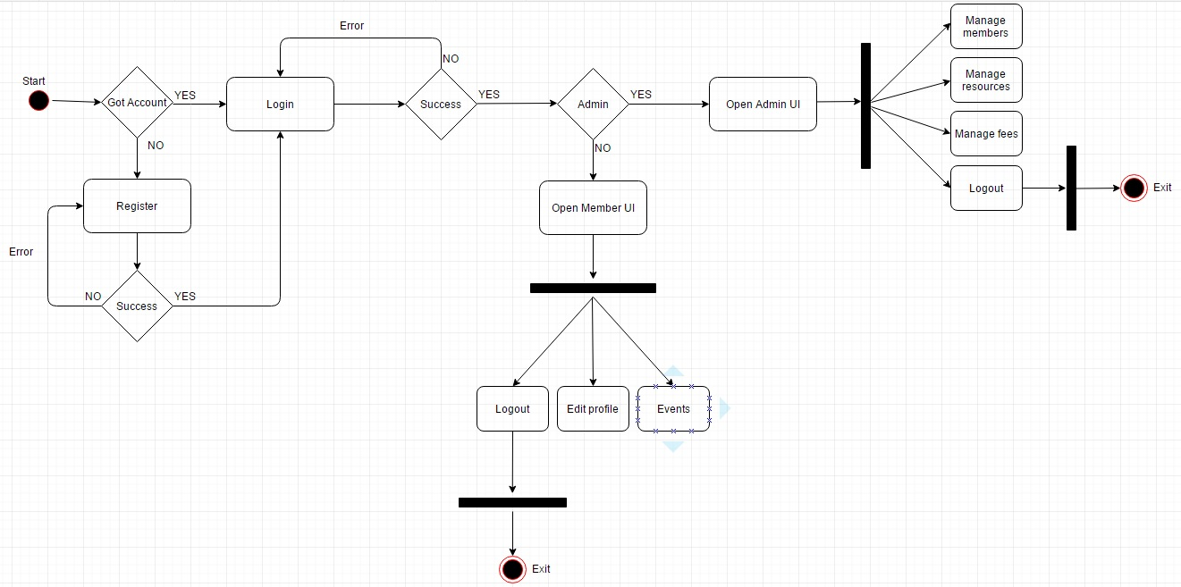

* *Top level use case diagram*

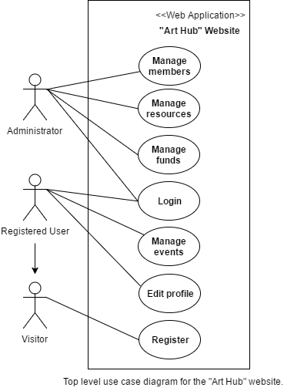

* *Detailed use case diagram*

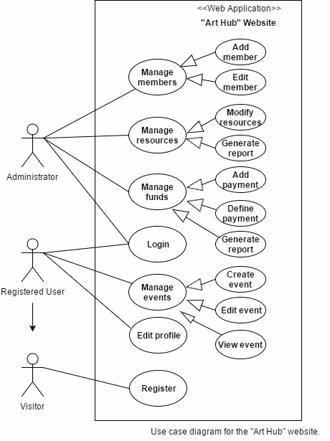

* *Class Diagram*

